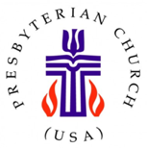

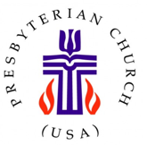
Monthly Prayer
Use your cell phone to scan this QR code and you will go directly to the Outville Presbyterian Church website!
For Your Information
FOR QUESTIONS OR PASTORAL CARE: Alice Karen Hite
Email: akhite80@gmail.com
Cell phone/text: 1 (740) 507 0545

CHURCH PHONE NUMBER: 1 (740) 927-7925
CHURCH WEBSITE: http://www.outvillechurch.org
CHURCH TELECONFERENCE NUMBER: 1 (617) 793-8569

THE NEWSLETTER –JULY 2026
THE OUTVILLE CHURCH
6463 Outville Road SW
Pataskala, OH. 43062
Join us for Sunday worship in-person or teleconference.
For teleconference, dial (617) 793-8569
Website: http://www.outvillechurch.org
we

FEBRUARY 2023
Join us for Sunday worship in-person or teleconference.
For teleconference, dial (617) 793-8569
Website: http://www.outvillechurch.org
we

If you have a story to tell or information to share with our Church community contact First M. Lastname at (555) 543-5432
Christian
church
YOUTH GROUP
MEN’S MINISTRIES
WOMEN’S MINISTRIES
MINISTRIES FOR SENIORS
INTERNET MINISTRY
GLOBAL OUTREACH MISSIONS
MUSIC MINISTRIES
FIRST M. LASTNAME, PASTOR
FIRST M. LASTNAME, YOUTH MINISTER
FIRST M. LASTNAME, SUNDAY SCHOOL
FIRST M. LASTNAME, GLOBAL OUTREACH
FIRST M. LASTNAME, TREASURER
FIRST M. LASTNAME, PRAYER CHAIN
FIRST M. LASTNAME
Pt iusto odio dignissim qui blandit praesent luptatum zzril delenit augue duis dolore te feugait nulla facilisi. Lorem ipsum dolor
sit amet, consectetuer adipiscing elit, sed diam nonummy nibh eui. Lorem ipsum dolor sit amet, connobis eleifend option congue nihil imperdiet wisi enim ad minim veniam possIm. Nam liber tempor cum soluta nobis eleifend option congue minim veniam, quis nostrud exerci tation ullamcorper. Nam liber tempor cum soluta nobis eleifend option congue nihil imperdiet doming id quod mazim placerat facer wisi enim ad minim veniam possim assum. Ut wisi enim ad minim veniam, quis nostrud exerci tation ullamcorpe
ipsum dolor sit amet, consectetuer adipiscing elit, sed agna aliquam erat volutpa. Nam lleifend optiodiet doming id quod mazim
placerat facer wisi enim.

Gracious God,
As we begin this new month, we place our hopes, our fears, our burdens, and our dreams into Your loving hands. Teach us what it truly means to trust You. When we surrender our worries to You, give us the faith to leave them there instead of picking them back up five minutes later.
Remind us that Your timing is better than ours, Your wisdom is greater than our understanding, and Your love never fails. When anxiety creeps back into our hearts, help us return to prayer instead of worry, to faith instead of fear, and to Your promises instead of our doubts.
May this July be a month of trusting more, worrying less, and walking confidently in the peace that only You can give.
In the name of Jesus Christ, we pray.
Amen.
Amen.


GOOD NEWS
IN THIS ISSUE
PRAYER FOR THE MONTH
EDITORIAL
LEADERSHIP UPDATE
SAVE THE DATE
MONTHLY CALENDAR
CONGREGATIONAL CONNECTIONS
ANNOUNCEMENTS
STRENGTHENING MISSION GIVING
IN THE SPOTLIGHT
FAITHFUL WORK

Mission Statement:
Outville Presbyterian Church strives to be a Christ centered growing and giving church by proclaiming Jesus’ love for all through our service to the community and the world.

This Photo by Unknown Author is licensed under CC BY-NC-ND
IN THE SPOTLIGHT

Reaching Every Generation
Making Room for the Next Generation

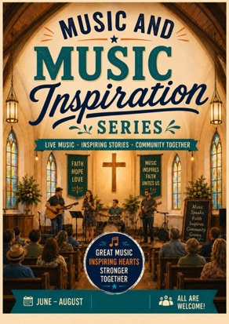

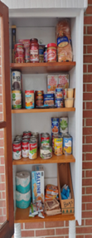
Today's churches are trying to reach people whose life experiences are very different from those of previous generations. Understanding those differences can help us discover new ways to share the unchanging message of Christ.

Generation X (Born between 1965–1980)
Generation X values authenticity, relationships, and community involvement. Many grew up in church but drifted away as careers and family responsibilities became priorities. They don’t like long meetings or wasting their time.
How can we connect?
- Personally invite friends, neighbors, and former members.
- Offer opportunities to serve the community together.
- Provide occasional discussions on real-life topics and faith.

Millennials (Born between 1981–1996)
Millennials seek purpose, relationships, and a welcoming place for their families. They are turned off when they feel their ideas are ignored.
How can we connect?
- Strengthen children's ministries and Vacation Bible School.
- Offer family-friendly events and service opportunities.
- Improve our website and social media so visitors can get to know us before they visit.

Generation Z (Born between 1997–2012)
Generation Z values honesty, belonging, and opportunities to make a difference. They notice hypocrisy and do not like being judged.
How can we connect?
- Invite young people to participate in leadership, music, technology, and outreach.
- Create opportunities for meaningful, two-way conversation and listening.
- Share authentic stories of faith through personal testimonies and social media.

What This Means for Our Church
Most of our congregation is over 60, and that is one of our greatest strengths. We have a lifetime of faith and wisdom to share. If we are willing to adapt how we welcome and invite others, while remaining faithful to the Gospel, Outville Church can become a place where every generation feels at home.

One of the realities we face at Outville Church is that most of our congregation is over the age of 60. That is not something to be ashamed of—it is something to celebrate. Our church is filled with people who have lived faithful lives, weathered life's storms, and continue to serve God with generous hearts. Those are tremendous gifts.
At the same time, if we hope for Outville Church to thrive in the years ahead, we must ask an important question: How do we help younger people know there is a place for them here?
Many of us grew up when attending church every Sunday was simply part of family life. Today, that is no longer the norm. Many younger adults have never developed the habit of attending church. They are looking for authentic relationships, opportunities to serve, and a community where they feel welcomed, valued, and accepted.
The challenge is not to change the Gospel—it is to change how we extend the invitation. We cannot assume people will walk through our doors simply because they know we are here. We need to meet people where they are, build relationships, and intentionally invite them into the life of our church.
The encouraging news is that we already have what younger generations are searching for. We have people who care, a church family that supports one another, and stories of God's faithfulness that deserve to be shared. What we need is the courage to share those gifts in new ways.
Each of us can play a part. Invite a neighbor to worship. Bring a grandchild or friend to a church event. Volunteer at Vacation Bible School. Welcome someone you don't know. Listen to another person's story before telling your own.
The future of Outville Church will not be determined only by who is here today. It will also be shaped by the people we welcome tomorrow. Let's work together to make sure every person—young or old—knows there is a place for them at Outville Church.
Sincerely, Cathy Ritchie

With sincere appreciation,

Summer Music and Inspiration Series
Our Summer Music & Inspiration Series continues through July and August! We'd love for you to be part of it.
You don't have to be a musician to participate. Share a favorite poem, an inspirational reading, a personal reflection, or invite a musician or singer to contribute. Every gift helps enrich our worship.
Please sign up on the sheet provided. We'd love to hear from you!

100% of your offerings support missions locally, nationally, and globally.
2026 Mission Giving

April–June Mission Emphasis: Hunger and Housing
As we enter July, the Mission Committee invites the congregation to continue supporting our neighbors through this month's mission offerings. Throughout July, 100% of the undesignated mission offerings will help strengthen local food ministries and community initiatives that provide hope and practical assistance to individuals and families facing food insecurity. Your generosity allows Outville Church to be the hands and feet of Christ in our community.
The Mission Committee extends its sincere thanks to everyone who donates food and supplies to the Blessing Box and faithfully helps keep it stocked, organized, and welcoming. We are equally grateful to the volunteers who pick up Panera's bread donation every Friday evening, prepare the bread for distribution, and warmly greet and assist our neighbors during Saturday morning's Bread Ministry. Your dedication makes a meaningful difference each week.
The committee is also pleased to report that mission giving continues to meet expectations. Remember that 100% of your mission offerings support the outreach ministries of our congregation. Our 2026 mission giving goal is $30,000, or $2,500 each month. As of May 31, mission offerings totaled $13,013.26, in addition to designated mission gifts.
The Mission Committee helps organize the "hands and feet" of our congregation's outreach efforts. While the annual Rummage Sale is our largest undertaking, the Blessing Box and Bread Ministry represent an ongoing weekly commitment to caring for our neighbors. Thank you for your faithful prayers, generous giving, and willing hands as we continue sharing Christ's love in practical ways throughout our community.

ANNOUNCEMENTS
STRENGTHENING MISSION GIVING
LEADERSHIP UPDATE
SAVE THE DATE

Session
The Session did not meet in June.
Deacon Board
The Deacons are dedicated to sharing Christ's love through care, compassion, and kindness. They welcome worshippers each week, helping ensure everyone has what they need for a meaningful worship experience.
Building and Grounds Committee
The Buildings and Grounds Committee continues to prioritize and schedule needed maintenance projects. Current work includes repairs to the Outville Road drain, the water heater chimney, drywall in the kitchen and Fellowship Hall, brick tuckpointing, exterior door repairs and painting, power washing the church, addressing water leaks beneath the Fellowship Hall, improving safety at the front entrance, replacing a dead shrub at the manse, and replacing the sump pump, which has already been completed.
The committee has an extensive list of projects and appreciates your patience and support as this important work continues. See Glenn Ritchie or Alice Karen if you have questions or would like to help.
Christian Education, Fellowship, Evangelism, and Outreach
The Committee is focusing on Vacation Bible School in partnership with Kirkersville United Methodist Church.
Music and Worship
The Committee continues to focus on its Special Summer Music program and would love to hear from you. See Jane Tutor, Lisa Mitchell, or Mary K. Franz to learn more.

LEADERSHIP UPDATES

Mission Study Committee
The committee reports that they are finishing up the final stages of the

2024 Committee
Chairs & Liasions
- Clerk of Session: AK Hite
- Deacons: Mary Ramey
- Education Grant: Mary Ramey
- Endowment: Mary Ramey
- Christian Education, Outreach, Fellowship and Evangelism – Carol Glaub and Alice Karen Hite
- Missions: Rory Utt & Cathy Ritchie
- Music & Worship: Lisa Mitchell
- Technology: Laura Brown
- Trustees: Alice Karen Hite

Men’s Lunch with the Tag-A-Longs – July 6th
At 11:30 a.m. on July 6th the men in our church community will meet at Denny’s near Kirkersville. Note the change in date from Tuesdays back to Mondays. Those who would like to “Tag-A-Long” are also welcome. See Tim or Melissa Lightle for more information.
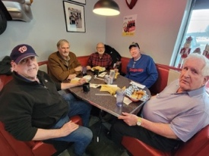
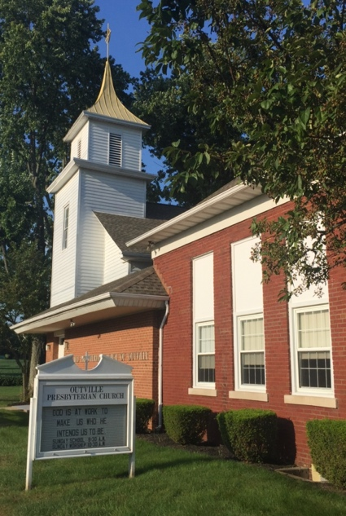

Vacation Bible School Planning – 4:00 pm, July 8th
While plans are still coming together, this year's Vacation Bible School theme is "Road Trip: On the Go with God."Join the Christian Education, Fellowship, Evangelism, and Outreach Committee as we partner with Kirkersville United Methodist Church to help finalize plans and make this year's VBS a wonderful experience for our children and community.


Invite a Friend Sunday - July26th
Join us on Sunday, Juuly 28th for Bring a Friend Sunday! Feel free to invite a friend, neighbor, or colleague to experience God’s love in person. A potluck lunch will follow worship.



2026 Committee
Chairs & Liaisons
- Clerk of Session: AK Hite
- Deacons: Mary Ramey
- Christian Education, Outreach, Fellowship and Evangelism – Lisa Mitchell
- Missions: Cathy Ritchie & Lisa Mitchell
- Music & Worship: Lisa Mitchell, Jane Tudor
- Presbytery Representative: Lisa Mitchell, Jane Tudor (Alternate)
- Property & Grounds: Glenn Ritchie & Alice Karen Hite
- Treasurer / Assistant Treasurer: Mary Ramey, Jane Tudor
Vacation Bible School – August 2nd thru August 4th
Vacation Bible School will be held in August from 6:00–8:00 p.m. and is open to children entering Pre-K through 6th grade. Vacation Bible School is one of our greatest opportunities to share God's love with the children of our community—and we can't do it without you. Whether you can help with teaching, crafts, games, snacks, decorating, or simply encouraging children, there's a place for you. See Lisa Mitchell if you are interested.


Rummage Sale Dates - September 17th thru 19th
Please help with setup on September 14–15, and September 16 if needed. Help is also needed during the sale. The sale gives items a second life, keeps them out of the landfill, and supports The Look Up Center in Newark.

OUTVILLE PRESBYTERIAN CHURCH MONTHLY CALENDAR

 | July 2026
 |  |  | 1 | 2  6:30 pm Trombones | 3  9:00 pm Bread Pickup | 4  10:00 am – Noon- Breads  Distributed
5 HOLY COMMUNION  9:30 am Bible Study – H  10:30 am Worship – H  11:30 am Fellowship-  Celebrate | 6  11:30 Men’s Lunch / Tag-a-longs at Denny’s   | 7  9:00 am PNC | 8  4:00 pm VBS Planning | 9  6:30 pm Trombones | 10  9:00 pm Bread Pickup | 11  10:00 am – Noon- Breads  Distributed
12  9:30 am Bible Study – H  10:30 am Worship – H  11:30 am Fellowship | 13  7:00 pm Crochet Group   | 14  9:00 am PNC  10:30 Missions | 15 | 16  6:30 pm Trombones | 17  9:00 pm Bread Pickup | 18  10:00 am – Noon- Breads  Distributed
19  9:30 am Bible Study – H  10:30 am Worship – H  11:30 am Fellowship  Noon Building and Grounds Meeting | 20 | 21  9:00 am PNC | 22 | 23  6:30 pm Trombones | 24  9:00 pm Bread Pickup | 25  10:00 am – Noon- Breads  Distributed
26 Invite a Friend  9:30 am Bible Study – H  10:30 am Worship – H  11:30 am Fellowship – Meal  11:30 am Deacons | 27 | 28  9:00 am PNC | 29 | 30  6:30 pm Trombones | 31  9:00 pm Bread Pickup

CONGREGATIONAL CONNECTIONS
FAITHFUL WORK: SEEN AND UNSEEN

Are We Willing to Try Something Different?
In a recent sermon, Rev. Taylor Barner shared a simple but powerful example from his ministry at The Ohio State University. Instead of waiting for students to come to church, they drag an orange couch onto campus. They simply invite students to sit down and tell their story. No pressure. No agenda. Just listening. Through that simple act of hospitality, relationships are formed and lives are changed.
It made me wonder: What would our "couch" look like?
Maybe it isn't a couch at all. Maybe it's a community meal, a coffee hour where everyone intentionally invites a friend, a game night, a service project, or simply sitting on the church lawn to greet neighbors. The point isn't copying someone else's idea. The point is being willing to meet people where they are instead of waiting for them to find us.
Most of us grew up in a time when the church was the center of community life. Today, that isn't true for many people. They aren't opposed to church—they simply aren't thinking about it. That means our invitation has to be more intentional and, perhaps, more creative.
We may not have the energy we once did, but we have something just as valuable: wisdom, experience, compassion, and stories of God's faithfulness. Those are gifts our community needs.
So here's the challenge: What is one new thing we could do to help someone feel welcomed, heard, or loved? It doesn't have to be complicated. It simply has to begin with a willingness to step outside our comfort zone.
The Gospel has never changed, but the ways we share it have always adapted to the needs of the people around us. As we look to the future of Outville Church, let's pray for open minds, courageous hearts, and the creativity to find our own "couch"—the place where conversations begin, relationships grow, and people discover God's love.
Who knows? One simple idea may become the beginning of someone else's faith journey.

Birthdays
07/06 Traci King
07/07 Donna Edwards
07/22 Barbara Hamilton
07/28 Greg Hite

Anniversaries
07/01 John & Patty Jude
07/03 Don & Sherrie Royer
07/23 Dwight & Carol Hite

Christian



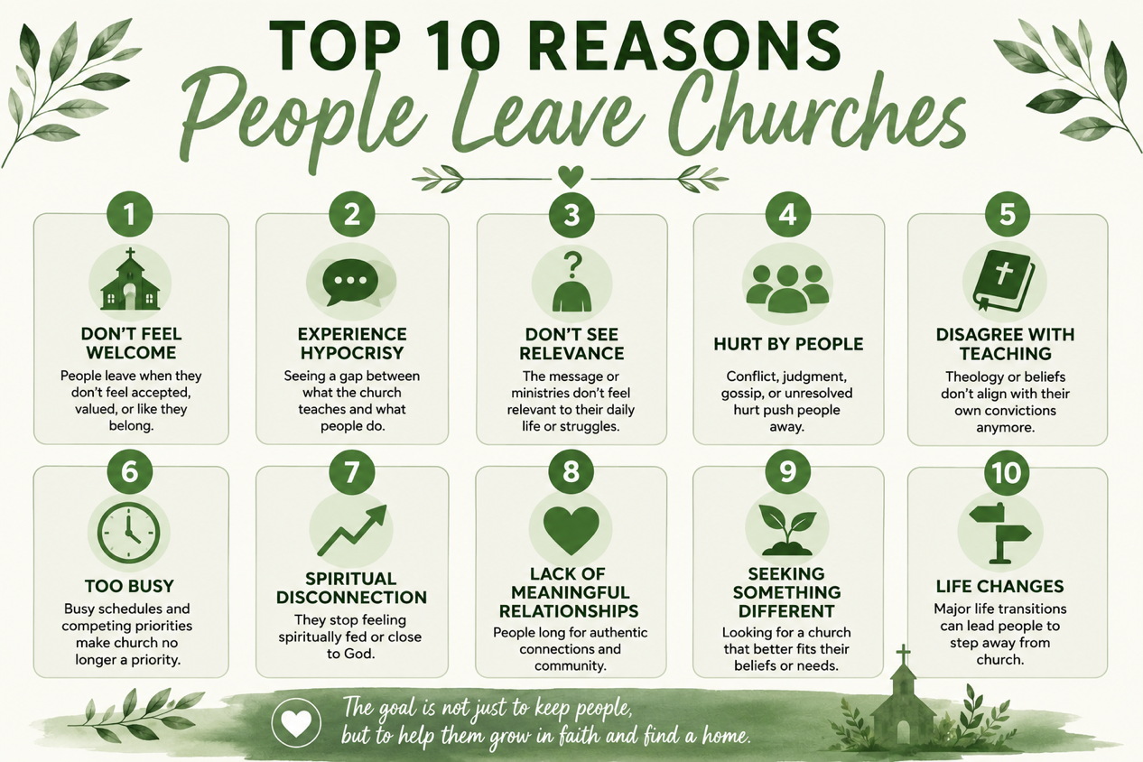
Please let us know of any birthdays or anniversaries we may have missed. Send to Alice Karen Hite at akhite80@gmail.com.

